

**Spring 25**

**CSE434 (UG2018) - Aspect- and Service-Oriented Software Systems (37100)**

**Lab assignment 3**

Name: Salma Nasreldin Aboelela Ahmed

ID: 20p7105

## Checking ceview in docker container

## 

## Checking docker running:

## A screenshot of a computer program AI-generated content may be incorrect.Listing databases on Docker CLI:

## A black background with white text AI-generated content may be incorrect.Connecting to ceview database:

## Checking tables:

**Testing Workflow Example**

1. Create a restaurant and save the returned UUID

1. A screenshot of a computer

   AI-generated content may be incorrect.Get all restaurants to verify it was created
2. 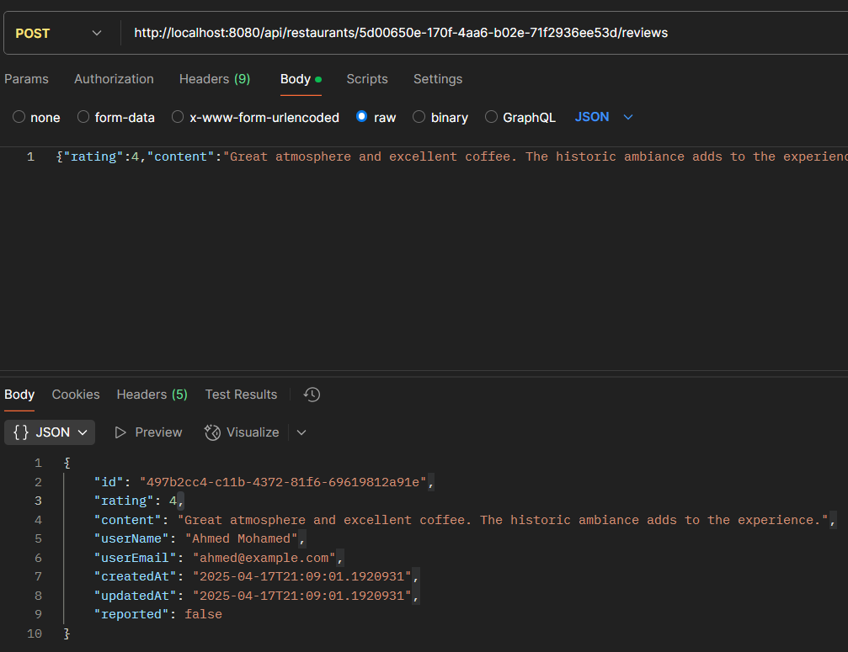Create a review for that restaurant using the UUID
3. 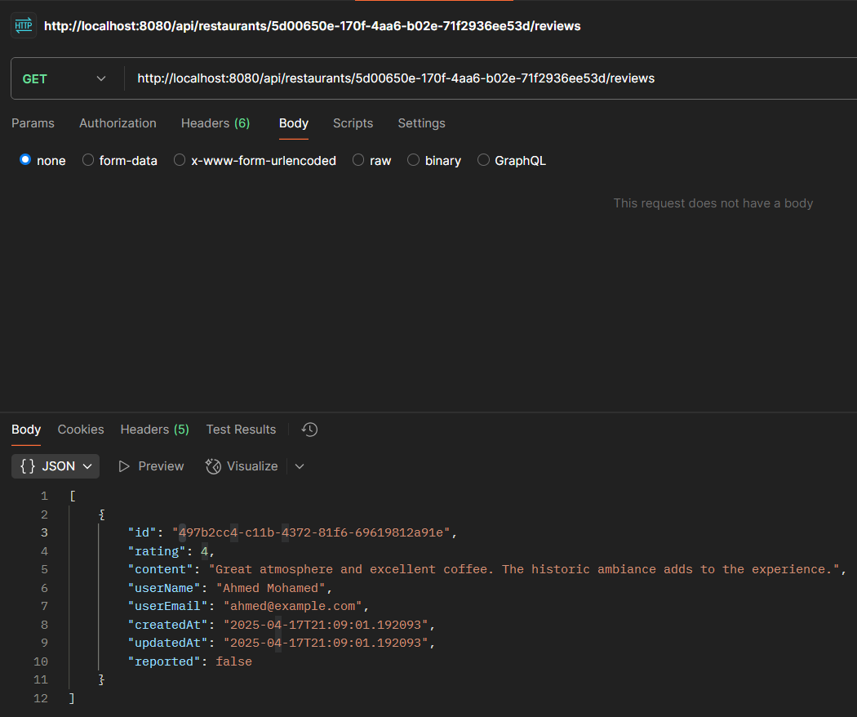Get all reviews for that restaurant
4. A screenshot of a computer

   AI-generated content may be incorrect.Update the restaurant
5. A screenshot of a computer

   AI-generated content may be incorrect.Update the review
6. 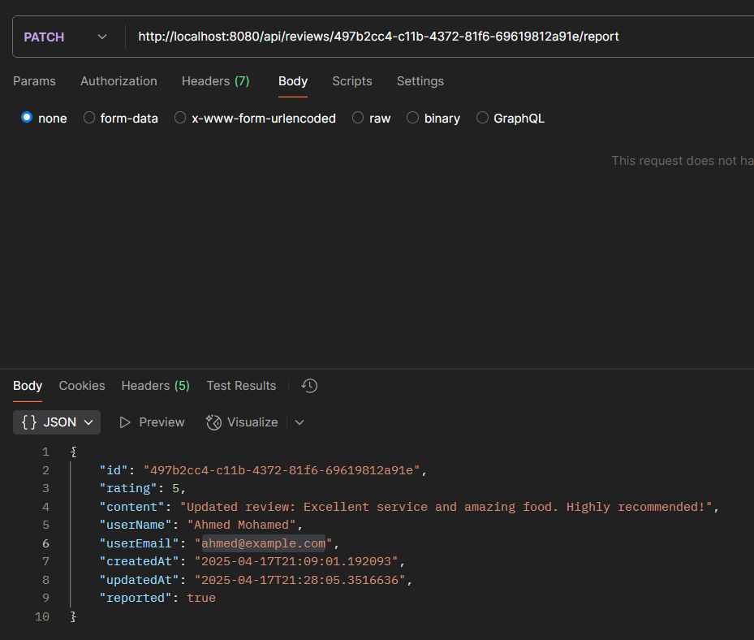Report the review
7. 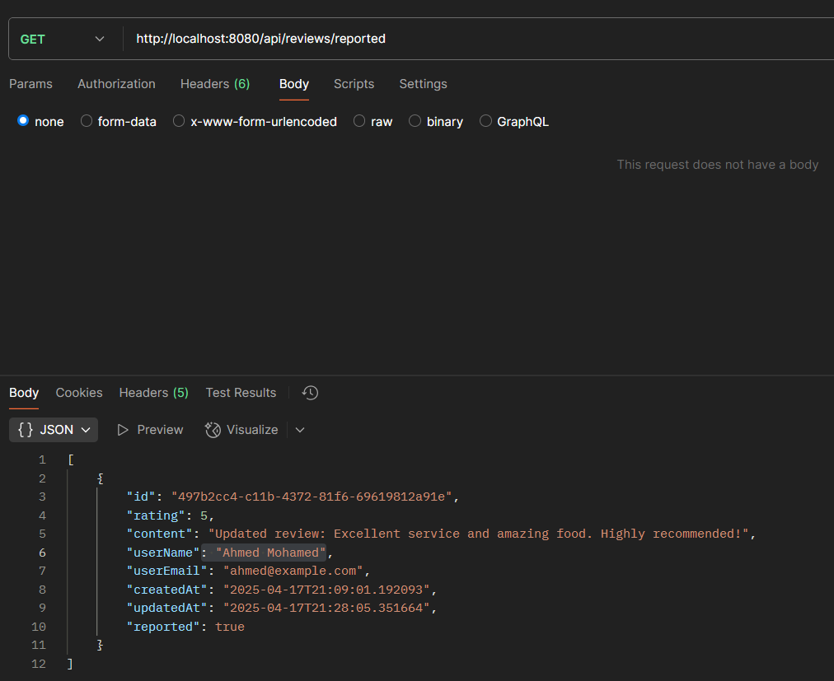Get all reported reviews
8. 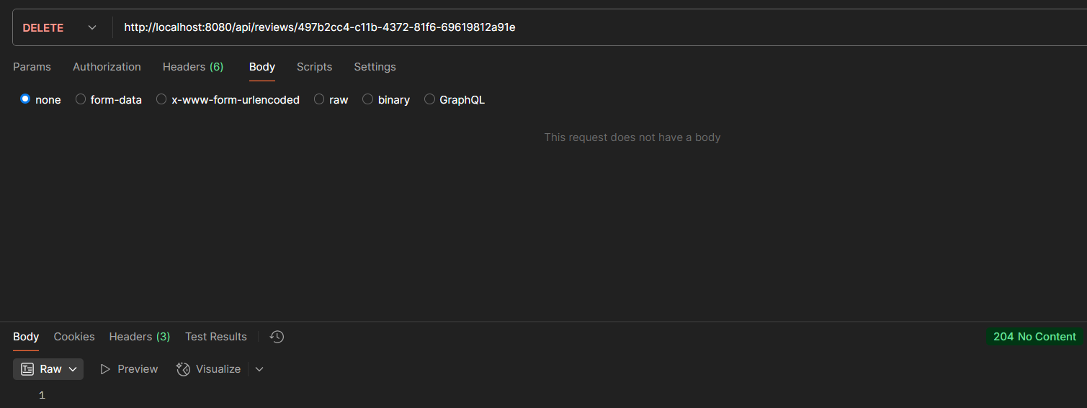Delete the review
9. Delete the restaurant

